
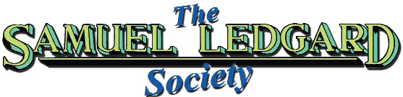
The Journal of

NOTICE BOARD 102 – AUGUST 2025
Welcome to our second issue of the ‘E’ News the first issue back in April was warmly received and we had several favourable comments sent in by enlisted members. At the moment we have 111 registered to receive the Chat by email.

Our SLS webpage, www.samuelledgardsociety.org.uk has recently been revamped, so check it out! It includes details how to register to receive the Chat – free to all! Spread the word to anyone you think would be interested in joining our happy band.

One of our ‘senior’ members, Peter Ashman from Barnsley was 90 in June and we extend our belated congratulations and best wishes to him.

Peter was in the National Children's Home and Orphanage in Bramhope, near Leeds from the age of 7 from 1942 until 1951. During his time there he first encountered Samuel Ledgard buses and coaches on outings – especially to Christmas pantomimes at theatres in Bradford and Leeds.

In 1946 he passed the entrance exam to Prince Henry’s Grammar School in Otley which was served by both Ledgard and West Yorkshire buses. He would often get home late due to letting a West Yorkshire bus go while he waited for the next Sammy’s bus! Peter well recalls the arrival of a batch of new double- deckers in 1949, MUA 860-862 and still has fond memories of Ledgard’s.

The home was closed in the 1980s and the listed buildings were converted into private houses renamed the Hilton Grange residential estate.

OBITUARIES
Once again, we sadly have to record the passing of the following members:

Peter Million, who died in March 2025. Until retirement he was a coach driver for Wallace Arnold Coaches and then Shearing’s Tours when they took over the well-known holiday touring company in 2005. His claim to fame was building a scale model of Ledgard’s Otley bus garage, the dimensions of which were exact to scale. Peter visited the old depot, which is now Kwik Fit tyres, and took all the measurements including the old fire station next door. No panic, the model garage is in the safe hands of fellow member, John Morris in Derby.

Paul Midgley also passed away sometime this year. He had the honour of being the member who lived closest to the SLS HQ here in Thorpe Willoughby and lived only a five-minute walk away.

He was the second member to receive his copy of the Chat, which was delivered personally by hand! Your chairman was first to get his sticky hands on his copy!

Society contacts
Barry Rennison
Tel. 07800 926262
e-mail: rennisonbarry@gmail.com
Tony Greaves
Tel. 0113 258 4795
e-mail: tonygreaves331@gmail.com
Published by The Samuel Ledgard Society. Copyright 2025

THEY JUST COULDN’T WAIT!
by Barry Rennison
Forgive me, but your chairman has held this grudge for 58 years and felt it was time to get it off his chest!
Looking through my model bus collection, I came across a Code 3 EFE model repaint of a London Transport RT, like the 34 that Ledgard’s operated. It’s in the livery that it would have looked like when West Yorkshire Road Car took over Ledgard’s in October 1967. Why on earth did the management at WYRCC choose not to operate some of Ledgard’s RTs instead of bringing back their own out-of-service older Bristol Ks and Ls we will never know?
Bus enthusiasts and West Yorkshire drivers missed out on lots of advantages of seeing and driving them in their new livery. Someone at the firm must have had a beef about Sammy’s – making 100 perfectly serviceable buses redundant. On the day of takeover, they erased the Samuel Ledgard fleet name from the side of vehicles and even man- aged to take down all the Ledgard bus stops overnight – they just couldn’t do it fast enough!
London Transport put their drivers first and as such the cabs of the RT types were de- signed for their comfort. They were the bees-knees, nice comfy driver’s seat for a start, light steering, cab heater, half drop signalling window at the press of a lever. Not that the latter was required as the buses had large trafficators on both the nearside and offside of the vehicle. The biggest advantage was the pre-selector gearbox giving nice gear changes – far superior to the West Yorkshire’s Bristol crash gearboxes! A driving duty shift on an RT was surely heaps easier than on a Bristol. It crossed my mind that WY may have been concerned that some of their drivers wouldn’t be used to this type of gear change. Not only that, drivers who preferred the RT to a crash gear change might try to choose his allocated bus by the traffic office.
When Ledgard’s finished it was a sad enough day for bus enthusiasts who could have done without some of the harsh actions that the WY management took, prior to and during the takeover, whoever they were! A suggestion of impetuousness by them springs to mind! It was strange really as both the companies had worked jointly with each other on two bus services for many years and shared ownership of the Otley bus station since it was opened in 1939.
There is no doubt about it the West Yorkshire management, engineering staff and drivers were denied working on a far superior vehicle compared to some others in their fleet. One thought springs to mind and it is certain that they missed out on a real driving experience!

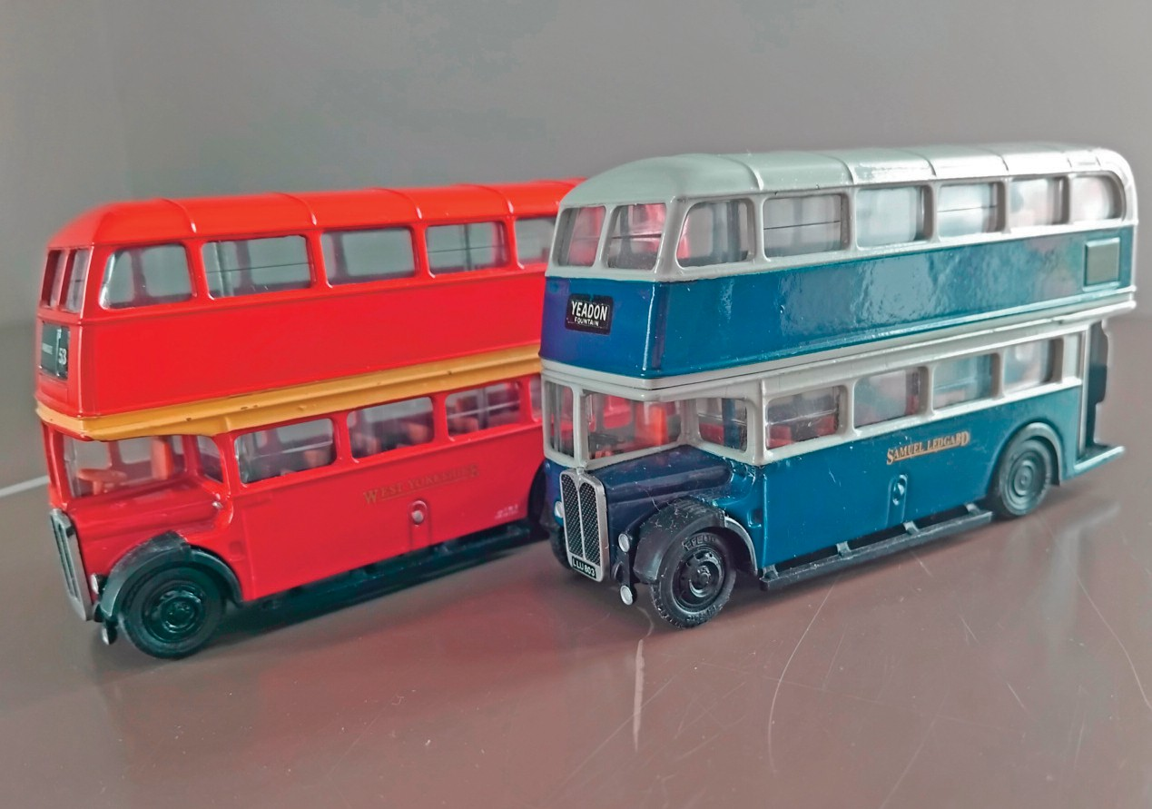

EFE RT models repainted in Samuel Ledgard and ‘what could have been’ West Yorkshire liveries.
Models and photos: Barry Rennison.

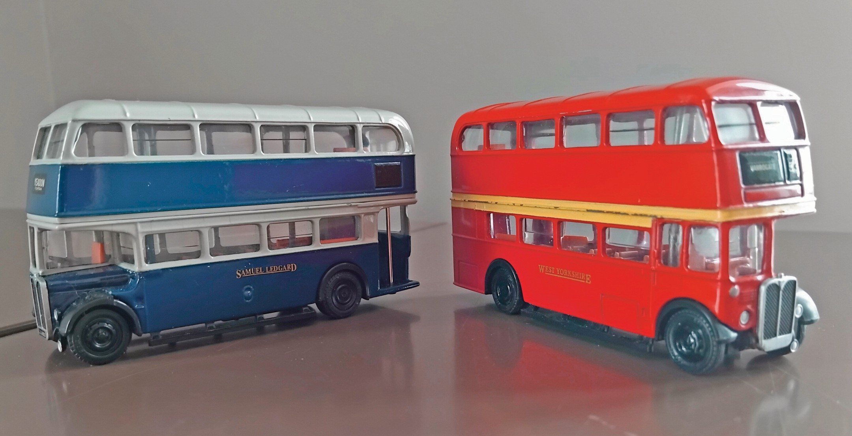

LEDGARD’S AND ME
by Neil Jameson, member 136
I was born in 1949 and as far as my memory serves, became aware of Ledgard’s Buses in about 1953. It was many years later that I was able to identify vehicle types.

We lived in Bramhope and when I started school, I took the Ledgard’s bus from The Poplars to the Church and walked up the hill to the school. Later when I started at the Juniors, it was one stop less and a walk up the ginnel. As I recall, it was always one- way and I walked back. There were no parents involved in those days of course.

On a Sunday, the route being Joint (34), it was usually a West Yorkshire bus which took me to the Church for Sunday school. This was often DX82 which stood out due to its front entrance. The weekday Ledgard’s bus was not recorded unfortunately.

Things became more interesting when at the age of 8, we moved to Guiseley. Here I attended Menston Junior school, using the Ledgard’s Bradford to Harrogate service, during the period when it seemed to be mainly single-deckers. These were often unequal to the task for the peak school journey from Guiseley Hawksworth Lane to Menston village.

One regular was what I later discovered called “Jumbo”, the twin entrance Daimler Freeline, LRW 377. Later we had the ex-Red & White Albions. At other times, on the return home, the ex-Kitchin’s Atkinsons might appear.
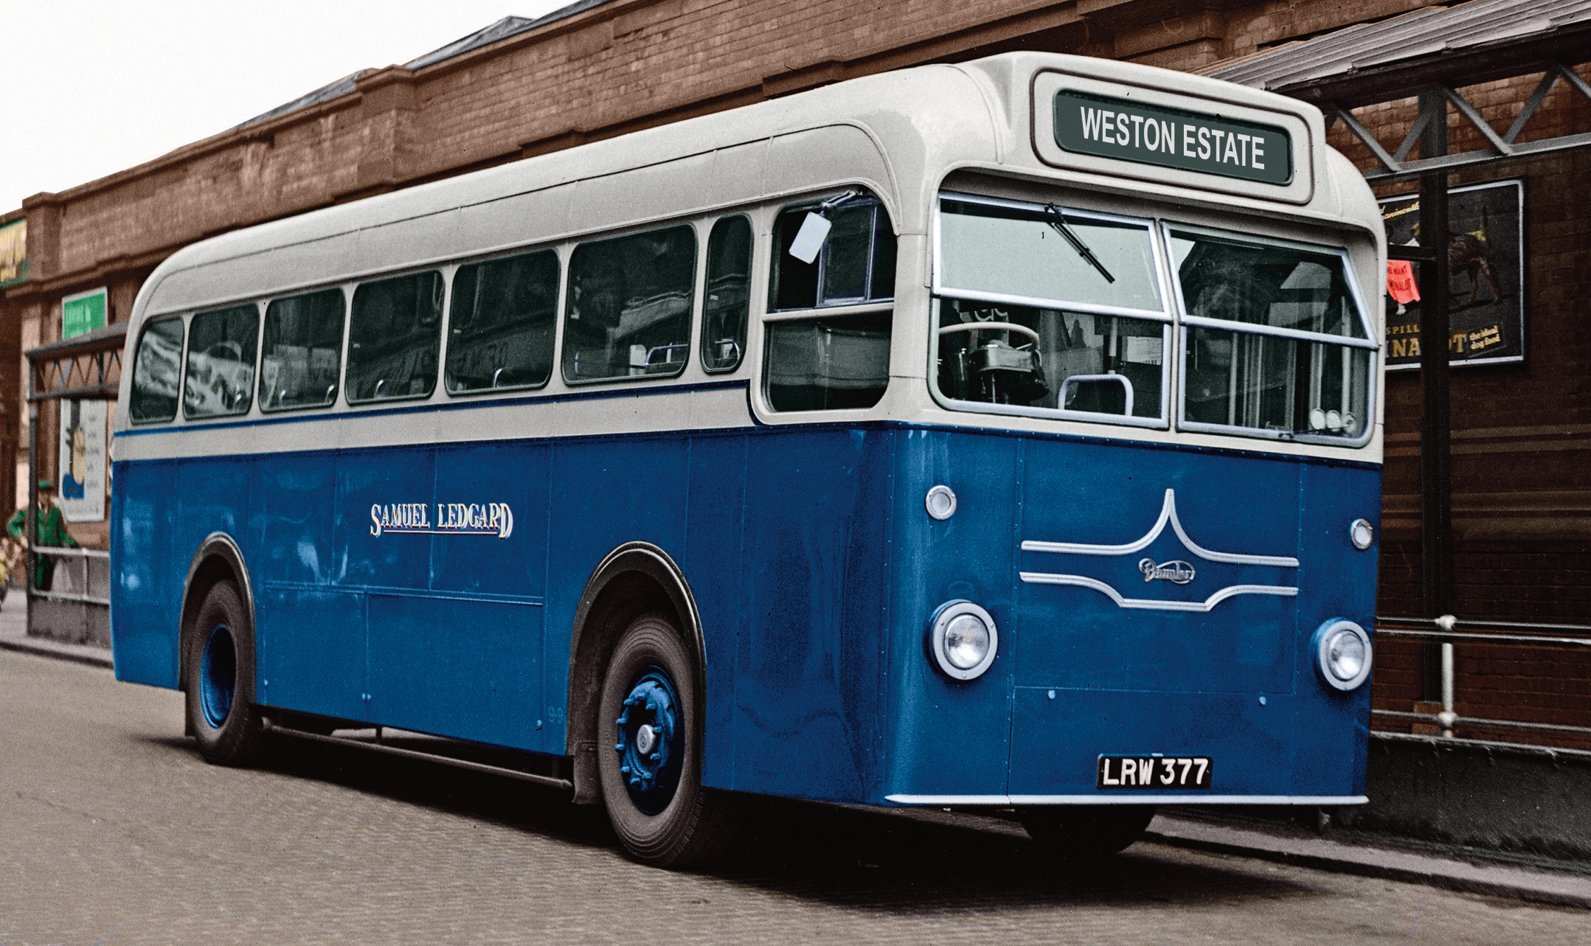

A colourised view of LRW 377 at Otley bus station. Photo: Garry Luck

I remember once in Menston village where the bus reversed. One of these Atkinsons stalled, and the conductor got us all off the bus to push it and jump start it in reverse!

Eventually, a school special was provided as a duplicate in the mornings and again in the afternoon from the school to and from Guiseley Hawksworth Lane. This was always a “proper bus” (double-decker), presumably from Otley depot. When I was 11, I was sent to Ilkley Grammar school and was issued with a WRCC “West Yorkshire” only bus pass, so I could no longer use a Ledgard bus without paying!

At first, I was on the West Yorkshire 63 service each way, but later I got a school special from Guiseley White Cross, just in the morning. This was always a West Yorkshire sin- gle-decker from Bradford Depot.

Regular buses were SBW35, SGL6 & SMG14. Because this wasn’t a service bus, we often seemed to get drivers who didn’t know the official route. So, we took great delight in sending them via the “short cut” under Ben Rhydding railway bridge and up the steep hill at the side of school to the main gate on Cowpasture Road.

There were times when the river was in flood that water came into the bus and covered the floor and buses like SBW35 took it their stride!

This advantage saved us the walk up from the river in Ilkley, my friends who lived in Horsforth were then issued with “Ledgard” only bus passes.

However, I had to stand at Guiseley White Cross every morning and watch all those wonderful buses going past, including the lowbridge Leylands and AEC RLHs from Moorfield depot on their way to Yeadon and Horsforth.
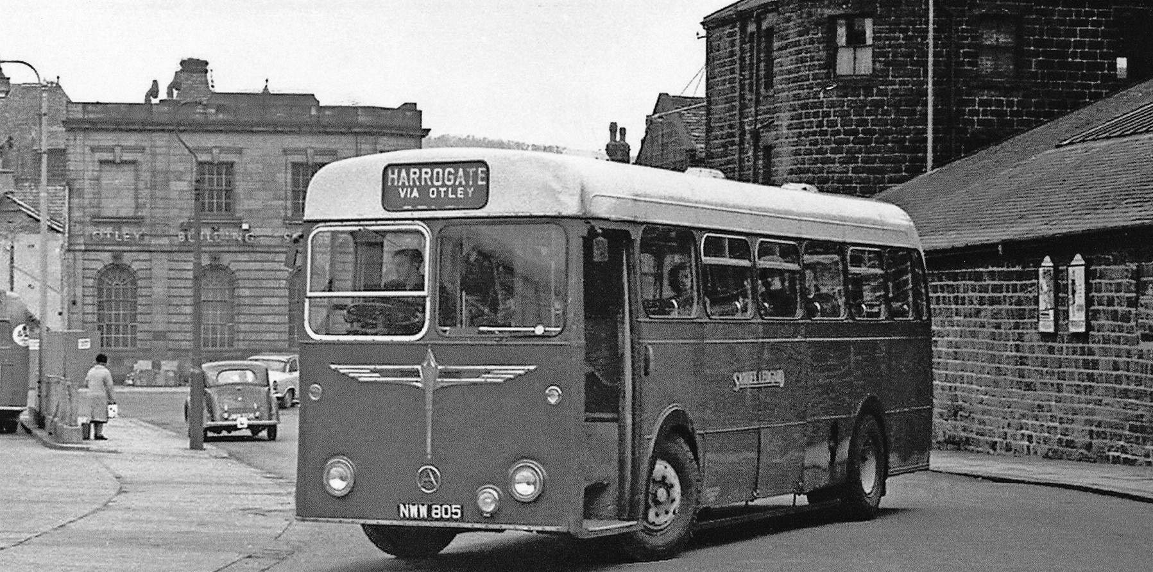
One of the pair of Atkinsons acquired with tha Kitchin’s of Pudsey business seen entering Otley bus station. Photo: TLP.

Then there was the range of the Ledgard fleet going to Ilkley, which changed a lot from 1962 to 1967, seemingly also every day. PNW 91 etc, 1949 U etc, MCY 405/8 & PDV 726/732 etc; and then came the magnificent RT & RTL fleet.

Strangely enough, we always seemed to pass the same Ledgard bus coming towards us around Burley, which was EN 8408, for a long time.

I could only watch and listen as they went past. In order to get my “fix”, I would go to Horsforth and Leeds by Ledgard whenever possible, at the weekends. A journey on the last Ilkley via Guiseley service from Park Place or get on in Horsforth and then have to walk home from White Cross, was always a youthful experience.

But suddenly, it was all over. The news broke of the pending sale to West Yorkshire. Rumours were rife, some promising, most not and as we know it was worse than any rumour. On the last day I went down to Otley and watched as 1953 U returned to the depot after its last run and for me it was all over.

I tried to ride on the AEC Regent Vs which West Yorkshire Road Car kept for a short while after the takeover of Ledgard’s, but it wasn’t the same. The routes changed and whilst I went away to Birmingham on a course, it was as if Ledgard’s had never been when I returned.
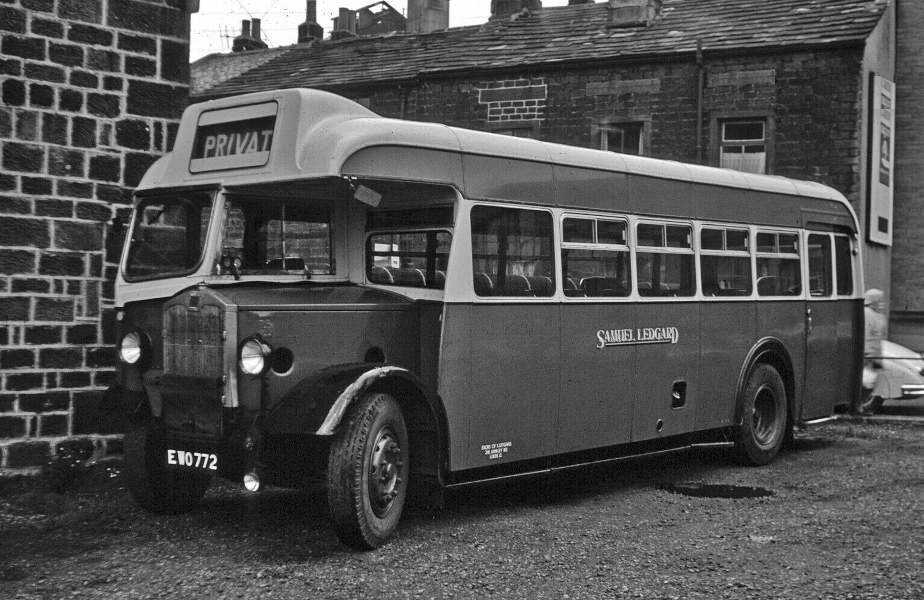
Ex Red & White Brislington bodied Albion EWO 772. Photo: SLS Archive.

QUERY CORNER by Archivist
Searching through the SLS archive three photos came up with a puzzling query. The photos were of three Ledgard coaches taken in Southend-on-Sea on almost consecutive years and raised a few questions.

All three were parked up in two of Southend’s car parks which seemed strange, what were they doing there? Was it a regular excursion that Ledgard’s did which was doubtful, it’s a bit far to travel for a day trip being a journey of 219 miles from Leeds without motorways in those days. There is no clue to suggest it was a holiday tour to the south. The best guess to answer this query would be a regular private hire for a group, club or association. Maybe an amateur football or rugby club – sadly, not many of us are left now to answer this poser. It did prove that the good old name of Ledgard’s showed their flag as far as the south of the country.

Both car parks still exist today, although Kursaal Way now has an entry height limit of
2.10 metres, so buses and coaches are no longer able to park there.

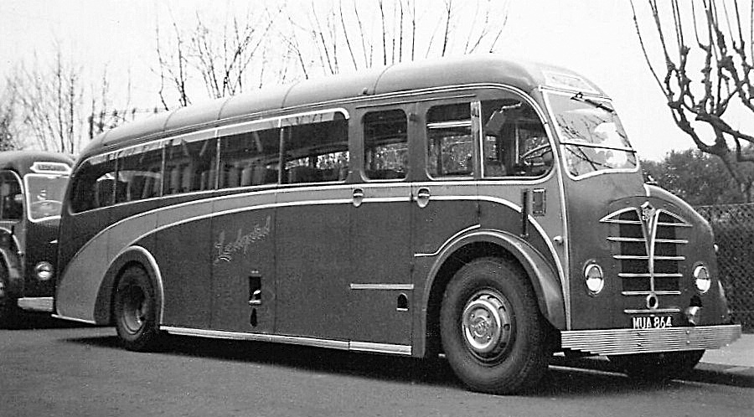
The location of MUA 864 is not known but its definitely taken in Southend and dated 25.4.1954.
Photo: SLS Archive.

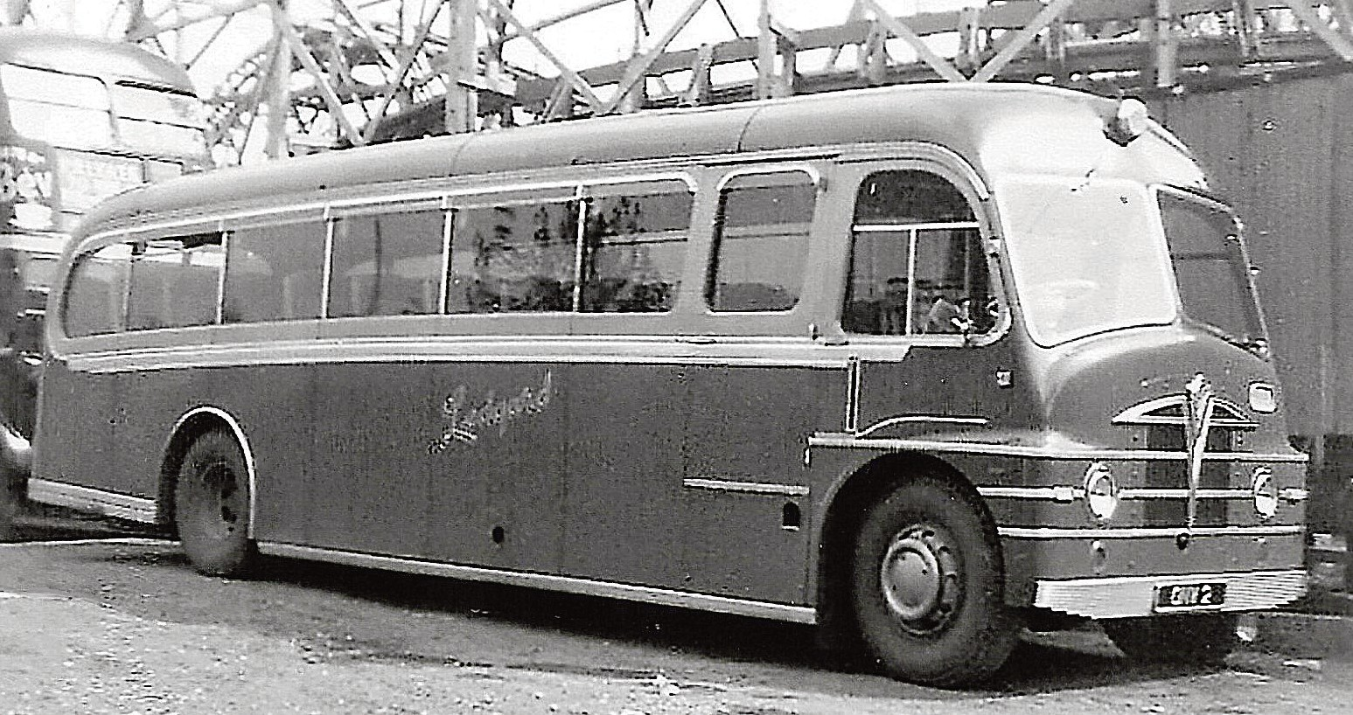
ONW 2 parked up in the Kursaal car park next to the Woodgrange Road fairground on 01.05.1955.
Photo: SLS Archive.

PICTURE VIEW -
THE NELSON OVER THE YEARS
The Nelson Inn was opened in the mid 1800’s and was known as that until 2011. It was a public house for over 120 years, so was in use for over 120 years. After closure it was offered for sale in 2009 with an asking price of £120,000. Following purchase by Raj Chaba, and extensive modernisation, it opened as an Indian restaurant called the Jaipur in 2010 by new owner, Raj Chaba.

Unfortunately, that didn’t last long until passing to new owners trading as the ‘Bongo Afrike restaurant’ in 2017.

Finally, two years later it once more changed owners and was renamed ‘Grand Valley bar and kitchen’. It continues still trading and open to date.
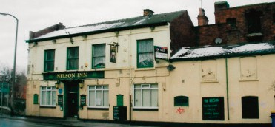

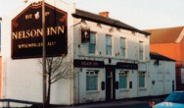
The Nelson Inn, as it had been for many, many years.
Photos: SLS Archive.

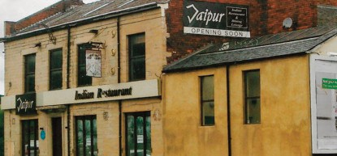

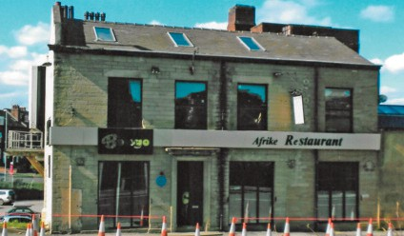
The Nelson Inn became the Jaipur Restaraunt for a short time and centre, in its Bongo Afrike restaraunt days.
Photos: SLS Archive.

The present day Grand Valley Bar and Kitchen.
Photo: Peter Larkham

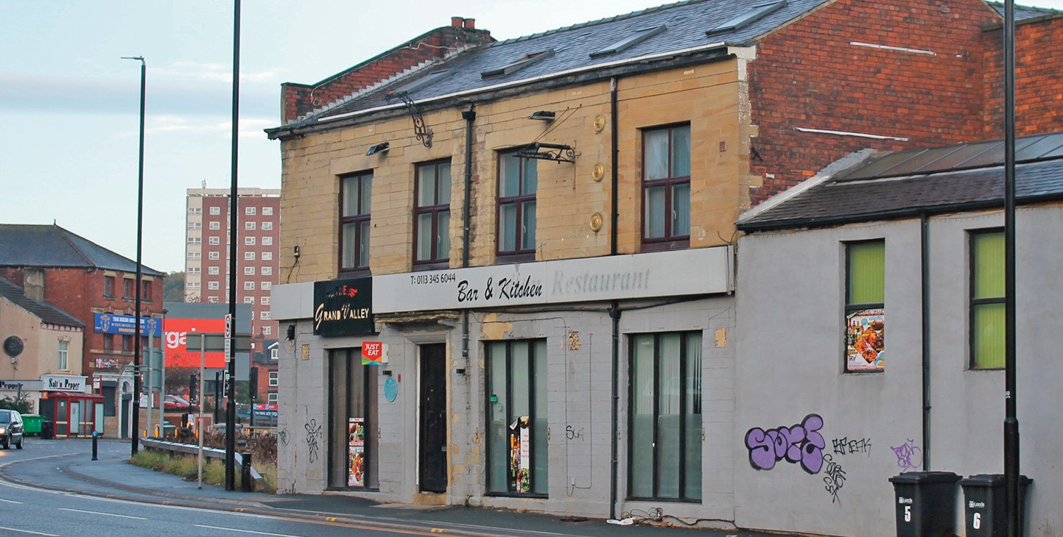

WHOOPS - ACCIDENTS HAPPEN

by Barry Rennison
One of Ledgard’s ex-London Transport Daimlers double deckers in the 1950s, HGF 949 driven by Otley depot’s Frank Crew of Cross Green, Otley was in collision with a car. The nine-horse-power vehicle was carrying eight young people returning from a 21st birthday party. It was in collision with the bus on Otley bridge. Sadly, the driver of the car was killed and the other seven, five girls and two men were injured.

The girls all worked together at Otley Mills and had been to a party at the home of Miss Shaw to celebrate her birthday. In the collision on the bridge the car, a 1936 model, sustained significant damage. The bus crashed into a parapet on the bridge but neither the bus driver nor any of his passengers were injured.

Presumably the bus was on the Weston Estate run to Otley bus station passing over the bridge which blocked the road. The attending ambulance was damaged as it scraped its way between the bus and the parapet to take the injured on a direct route to Otley hospital rather than make a seven-mile detour.
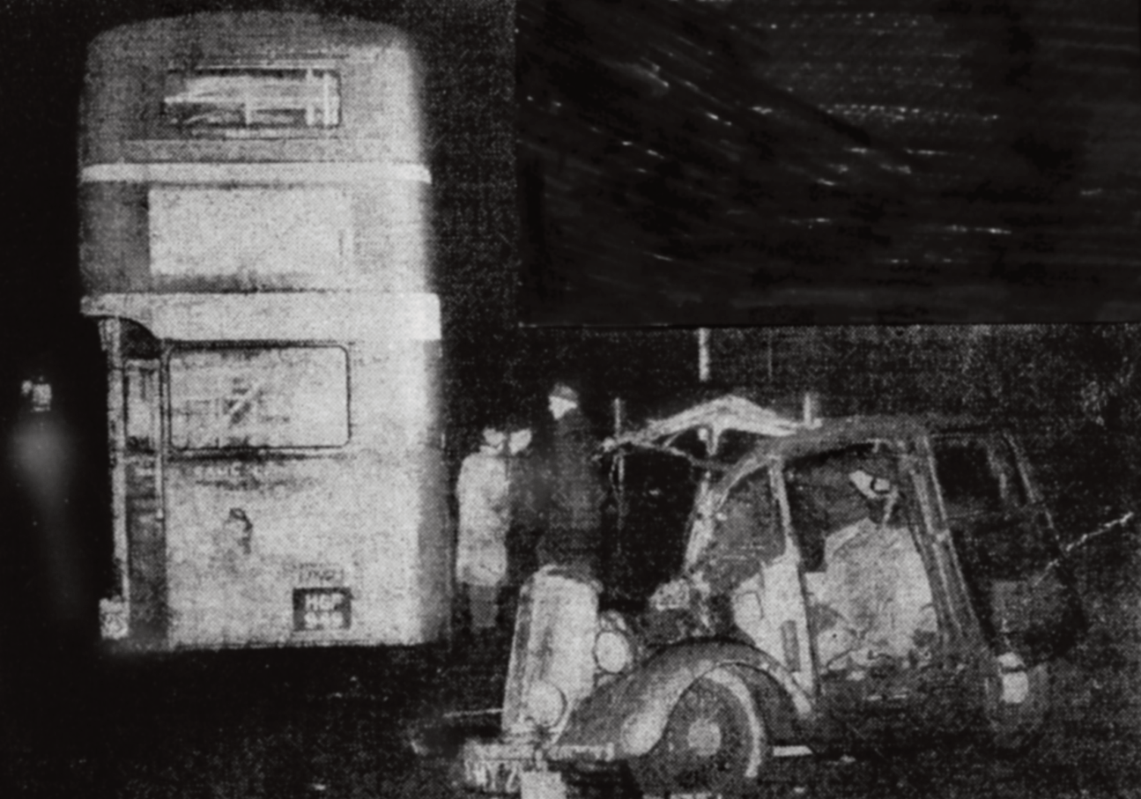
Under the Data Protection Act 1984, the Society gives notice that membership information is held on computerised records.
The Society undertakes that this information is not divulged to any outside agency or individual.
The opinions expressed in this publication by contributors do not necessarily reflect those
of the Committee.

SAM’S ROLLER

by Barry Rennison
It is no secret that Samuel Ledgard was a hard-working man and over the years his toil was somewhat rewarded by the addition of a particular vehicle to the fleet. But he had to wait a long time, over forty years in actual fact!

In June 1939, Sam visited motor dealers, Rippon Bros. Ltd in Huddersfield with the intention of acquiring a new car. They were main agents for Rolls Royce and he took a fancy to one. Later that year, during a visit to the Earls Court Motor Show, he signed on the dotted line for the supply of a certain Rolls Royce Wraith, series ‘C’-138 motor car.

Being wartime, delivery was somewhat slower than you would expect when or- dering a car. However, the wily Sam negotiated a special term of payment of the deposit which was extended on two occasions, and this was to be paid no later than 31st December 1939. It looks like he paid this deposit of £882.11 shillings just in time on the 21st December.

Thanks to the assistance of the Rolls Royce Enthusiasts Club, who provided a copy of the specification of this vehicle, I am able to list them and give some his- tory also.
The chassis, number WEC59 was delivered on 1st August 1939 to Rippon Bros via LMS goods train to Huddersfield. Nothing too fancy for Sam as the specifi- cation was all standard – Dunlop tyres Fort ‘C’ pattern, wheelbase and steering column. Even the bonnet and hinge mouldings were to be only standard!

The bodywork was built in Huddersfield with the springs ordered for a touring limousine, weighing 14cwts, seating 4/5 passengers but Sam informed them that there would usually only be 3. Sam also mentioned that the car would only be used in the United Kingdom for town and country use.

A spare wheel carrier was requested to be on the offside of the car which was installed at no extra cost. However, the mascot to the radiator cap was specified and this was charged extra at a cost of £3. The price of the chassis was £1100, but there is no record of the total price paid to include the coachwork.

Sam must have been patient because due to the ongoing war the vehicle was not completed until 1941 and evidently, he didn’t take delivery until October of that year. It carried the Leeds registration of JUA 150.

Sadly, no photographs can be traced of it, but presumably it was painted black, as most vehicles of that time were.

It is known that Sam drove his car at times but also employed a chauffeur at that time and there is one story to tell. That is on one particular occasion the Rolls was reversed out of the Armley depot up Lamb Hill onto Armley Road. Unfortu- nately, at the same time a Leeds City Transport tram was passing, and the two vehicles collided. No record of any damage to either was recorded nor will we ever know of who was driving – Sam or his chauffeur!

My thanks go to the Rolls Royce Enthusiasts Club, who hold extensive records on vehicles built, for the information held by them on Sam’s Roller. They have traced the car further in that it was exported to the United States at some time. Also, they say that it is very rare that their products are rarely scrapped – it would be nice to know if it still exists there today.
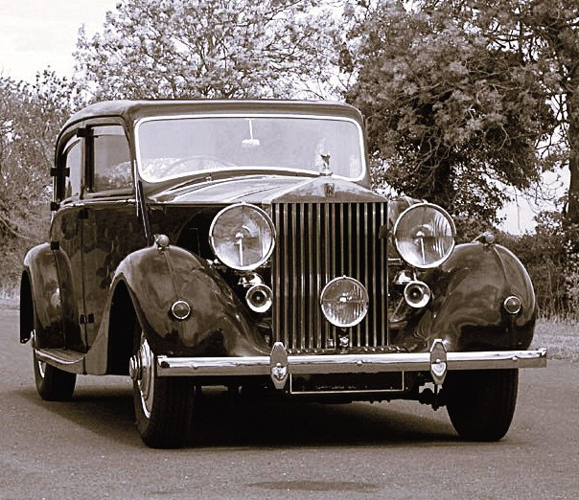

A similar Rolls Royce Wraith to Sam’s. Photo: SLS Archive

LEDGARD MODEL BUSES

by Chris Hough
The makers of proprietary model buses have been surprisingly kind to Ledgard enthusiasts with seven of the fleet being reproduced in model form. The very first was a 50th scale model of an AEC Regent/Regal rebuild produced by Corgi. This bus was FWJ 938 which Ledgard bought in 1956. It carried the wrong registration number which should have been FJW 938. It had been new to Birmingham City Transport as their 373, OG 373, a 1930 AEC Regent with a 48 seat English Electric body and petrol engine. Following the second world war Don Everall the well-known Wolverhampton based coach operator had the chassis re-engined to run on diesel and rebodied by Burlingham with 33 coach seats and a front entrance. Ledgard acquired the coach from Stubbs of Tunstall in the Potteries in 1956 and it lasted in the fleet until 1960.

While the Corgi model is an interesting model of an obscure vehicle, it misses the mark in several ways. The lack of legal lettering and any information on the boot lid about the telephone number stands out. The then current Trafalgar blue and black coach livery is nicely captured, but on the whole, it just misses the bullseye.

In 1987 a new company appeared selling OO scale model buses. This was EFE (Ex- clusive First Editions). Not unsurprisingly their first model was a London Transport model. In this case an AEC RT. EFE have used this casting to depict RTs from as far afield as St Helens, Hull and Coventry plus several depictions of RTs that never existed such as one for Midland Red. Unfortunately to date there has been no Ledgard RT. EFE followed up on the RT with a Leyland RTL One of the models issued depicts KGU 263, a genuine Ledgard bus when it was working for Silver Star but no Ledgard version has ever appeared.

Ledgard enthusiasts had to wait until 1994 for their next model. This was a model of an all Leyland Titan PD1. The body shape was captured very well but the model was let down by the very thick and somewhat out of scale radiator. The model was devoid of number plates but sported the correct legal lettering and fleetnames included on the rear lower panel plus a very accurate destination blind showing Bradford via Chapeltown both at the front of the bus as well as over the platform.

A batch of six PD1s was received by Ledgard’s in 1946 registered JUM 376-JUM 378. Seating 56 the trio lasted until the mid-sixties with JUM 376 and JUM 378 leaving the fleet in 1964 while JUM 377 lasted one year longer, bowing out in 1965.

In 1961 JUM 376 had its seating capacity increased by 2 giving a H32/26R as opposed to the others which remained at H30/26R. In the nineteen sixties many second-hand

PD1 chassis were placed in service from a variety of operators including Preston Corporation, Ribble Motor Services and Bristol Omnibus.

The last of the Bristol examples left the passenger fleet in the mid-sixties but several of the Preston and Ribble examples survived to the end.

By now Corgi, the other major toy and model manufacturer in the U.K had brought out their own range of model buses. These include ECW bodied Leyland Titan PD1s and a Bristol K. Both types could have appeared in Ledgard livery as they were part of the fleet in the sixties. Sadly, to date none have been released.

The next Legard vehicle to grace the manufacturers catalogue was an EFE issue of an AEC Regent V with Weymann bodywork which appeared in 1995. The bus now carried a registration number MCY 408 and a destination blind for the Bradford to Leeds via Pudsey service and looks realistic. However, there was a glaring error when a rear destination blind was also shown on the model. The real vehicle had been new in 1955 to South Wales Transport as their 448 and was purchased by Ledgard in 1967 just before the firm’s demise.

Ledgard bought a total of 4 of these A.E.C.s from the valleys and they all passed to West Yorkshire in 1967. They were repainted in Tilling red and cream and moved to Harrogate where they ran on town services. All had gone to the great garage in the sky by 1969. EFE produced two versions of the model in West Yorkshire colours fleet number DAW2 (MCY 408) with local Harrogate destination Oatlands while DAW1 (MCY 405) was depicted on the Newall and Westbourne Estate Otley local service. Once again both models had rear destination displays.

In 1999 EFE introduced a generic utility double decker which has been issued as both a Guy Arab and a Daimler CW type although none has ever worn Ledgard livery. I feel that an ex-London Daimler would be an ideal model to issue. In the case of ‘me tooism’ Corgi/OOC also issued a utility decker but no Ledgard examples have been produced.

As the new millennium dawned there were no Ledgard vehicles issued by any of the major manufacturers, Corgi and EFE had been joined by Creative Master Northcord who concentrated on modern vehicles and Britbus who issued an eclectic series of models but none of Ledgard.

The first Ledgard vehicle depicted in the new century was a Leyland Titan TD1 UB 5746 of 1931. This, and similar buses were Ledgard’s first double-deckers. The quartet had long lives by the standards of the day, lasting until the mid-1940s. Although their lives may have been truncated earlier if it wasn’t for the second-world war, when new vehicles were very difficult to come by.

The model is attractively finished in Legard blue and white with a green roof to mimic the canvas covering applied by Ledgard. The detailing includes a hackney carriage plate showing the registration number on the rear platform window and a depiction of the then Leyland trade name plate on the bottom of the radiator and accurate legal lettering and phone numbers on the lower rear panel of the platform. The destination showed Bradford via Pudsey at front and rear.

In August 2007 Corgi OOC issued what has been to date their only Ledgard vehicle. This was a model of 1949 U, one of a batch of six AEC Regent Vs with attractive Roe bodywork. The originals entered Ledgard service in 1957 and would be the last new double-deck buses.

All four passed to West Yorkshire in 1967 and saw further service, all receiving WY livery.The OOC model was painted in the livery in which the four were delivered. This was blue with a cream band above the lower deck windows and a narrower one below the upper deck windows. The roof was green to mimic the green canvas of earlier years. The model was offered with a choice of destinations, either Leeds via Otley or Ilkley via Guiseley although both models carried the same registration plate.

One year later EFE produced a model of a London Transport AEC Regent III of the RLH class, initially in London livery but in 2008 a model of KYY 508 appeared in Ledgard livery. The original of this bus was one of a quartet of these very non-standard London buses bought by Ledgard’s to work from Yeadon depot. Indeed, the four were only very rarely seen any- where other than the Horsforth to Otley service. KYY 508 joined the fleet in 1966 and was still in the fleet at closure. Three of the quartet KYY 504/506/508 were exported to the USA and as far as is known they are still in existence. To celebrate 10 years of the Ledgard Society the model was re-issued in 2009 it carried adverts for the society with the banner ‘1998-2008 Ten Years of the Samuel Ledgard Society’.

In 2016 Atlas Editions, who produced models aimed at their mail order customers brought out a Plaxton Panorama bodied Leyland Leopard in the final light blue and cream coach livery. This was modelled on AUM 414C and one of a pair of Leopard coaches hired from the well-known dealer Stanley Hughes. The hire was for a period of three years. Both were returned to Gomersal in 1967. AUM 414C had a long and varied career in several fleets including Wilson of Carnwath in Scotland. The actual model was a decent casting derived from a Corgi OOC model. However, the wheels were much too small being based on those of a Bedford VAL which spoilt the look of the model.

Editor’s note: Bedford wheels were fitted in error by the Chinese manufacturer - but in this case they weren’t wholly to blame, as the original Corgi two axle model Plaxtons shared the same reference number as the Bedford! All the two axle versions had an engine cover at the front of the seating unit which led to the front nearside seat being a single. I’ve driven many Leopards but I never saw one like this!

I was involved in the production of the Atlas range, as well as suggesting and providing livery details for most of the Corgi OOC and EFE Ledgard models. Other errors occurred, such as the EFE PD1 having an amalgam of ‘green roof’ livery and the final livery. All I could do was submit the details and wait months for the model’s appearance in the hope that all would be correct. It was also frustrating that there was no consistency. For example, the blue and grey livery differed hugely between the MCW Regent V and the RLH.

In 2017 Oxford Diecast, a recent entrant into the world of OO scale model buses issued a model of an all Leyland Titan PD2/12 in Ledgard colours. This was PNW 91, the first of a trio delivered in 1951 and the last buses ordered by Samuel Ledgard himself. The model carries the as new livery of 1952, blue with white window surrounds. The rear panel carries the company name and telephone number.

To date no other Ledgard vehicles have been issued by any manufacturer and following some years of economic uncertainty most companies concentrate on London Transport buses, either AEC Routemasters or Borismasters in various liveries.

As well as EFE with the RT and RTL and utility Daimler and OOC with the ECW Leyland PD1 and Bristol K other models which Ledgard ran have also not been issued in Ledgard livery. From EFE the Duple bodied Leyland Tiger coach could depict one of the 1948 LUB registered coaches prior to rebuilding with full fronts. OOC have a number of models that could depict Ledgard vehicles. These include an exposed radiator MCW bodied PD2 like GTY169, the former Tyneside PD2/12 bought by Ledgard in 1966.

Finally, Oxford diecast issued a model of a Bedford utility OWB which would look good in bought in 1951 and the last buses ordered by Samuel Ledgard himself.Ledgard blue and lastly a Leyland Royal Tiger with Duple Roadmaster body. Sadly, as the enthusiasts who actually remember Ledgard as a company enter their later years demand for the company’s models will diminish so unless you are good with a paintbrush these few may be as good as it gets.

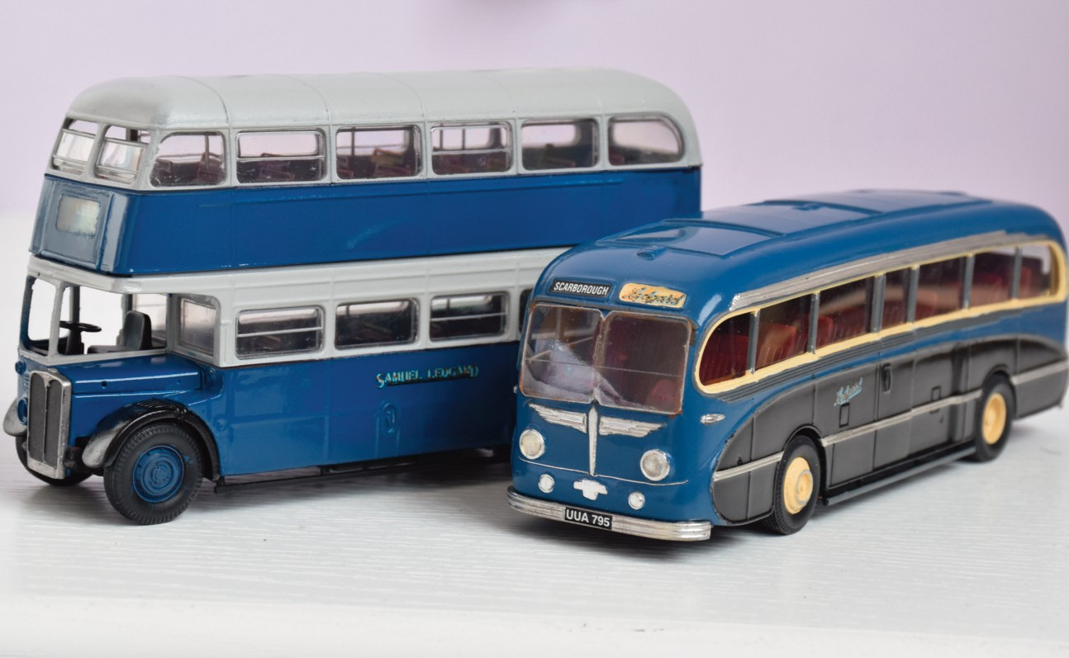

Corgi 1/50th scale models reworked and repainted as Ledgard vehicles. They are still not quite finished, despite work starting over 20 years ago! The Leopard coach was originally the Yelloway Bedford VAL and will eventually gain headrest covers to every seat, as well as a set of ‘stainless steel’ wheel trims.
Models and photos: Tony Greaves.
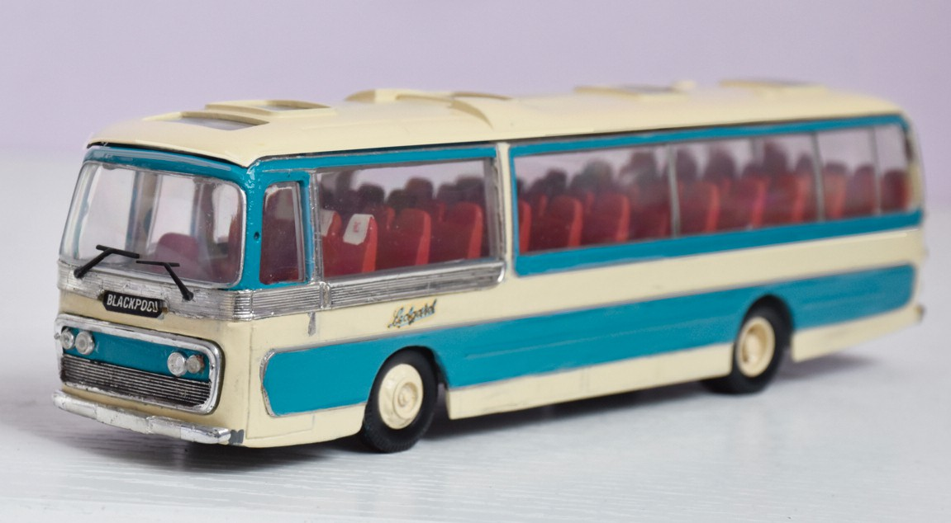

WEST YORKSHIRE’S NEW TRANSPORT NETWORK AND BUSES
West Yorkshire Combined Authority have recently announced the fleetname that they will be known as ‘Weaver’ – whatever that relates to! (Could it be a reference to the nature of the network, highlighting the number of direct, reasonably speedy routes?) They have also been inviting tenders for the acquisition of up to 450 buses in batches of at least 40 vehicles. The Authority requires them to be delivered prior to each of the three tranches that are planned to commence operation in April 2027, January 2028 and October 2028.

It too is seeking a range of single-door buses but no mention of seating capacities re- quired have been outlined, although they could be converted from dual door. Unlike Greater Manchester’s Beeline concern where they have been receiving hundreds of brand-new vehicles, WYCA will have a more relaxed age limit of no more than thirteen years old. When operations commence, they will ultimately aim for an average age limit for the fleet of around eight years old.

The authority specifically mention that they would prefer Euro V1 diesels or electric buses, but would consider Euro V. Their budget mentions £22m, so if that is for all 450 buses this would equate to just under £49,000 per bus.

Interestingly the livery chosen is several shades of green, at least in memory of the colours of Leeds City Transport. One downside is that the lower panels are awash with various vinyls with all sorts of shapes. No doubt these will take a fair bit of damage and prove a nightmare for the body builders to repair.

What ‘goes around, comes around’ comes to mind about their intended 13-year-old fleet of buses. Looking back Samuel Ledgard’s fleet averaged roughly that same figure. Could that be a rehash of our beloved bus operator and, if so, why couldn’t they have resurrected the ‘LEDGARD’ fleetname? No chance, the powers that be will not have heard about them!”

Editor’s note: I have been a Graphic Designer with an involvement in the bus and coach industry all my working life and, quite apart from the practical problems of the proposed livery in my opinion it is simply a mess, it does nothing to attract passengers and I sincerely hope it is replaced before it is due to be introduced.

WYCA please think again.

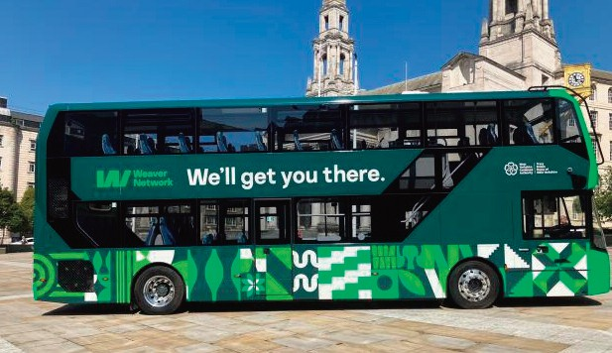
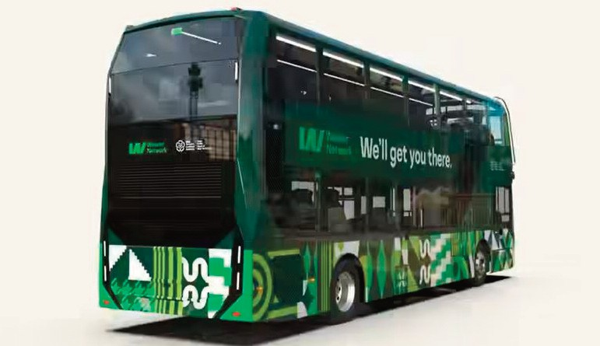
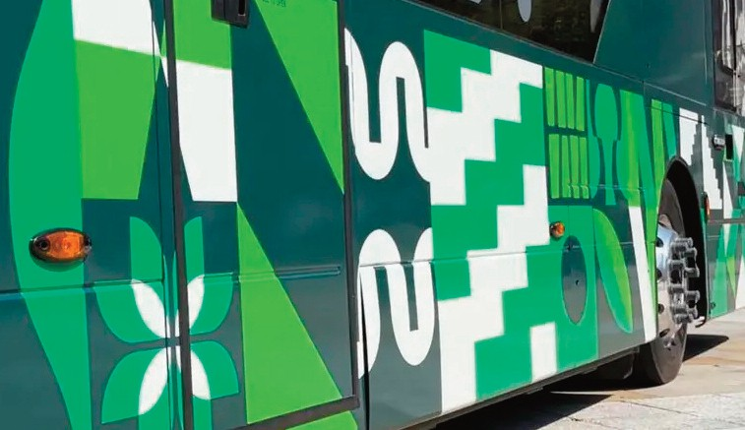

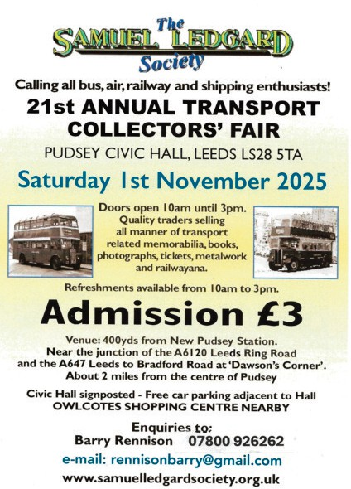

UPDATE ON NEW BUSES IN MADEIRA
by Barry Rennison
For the third time in 2 years, I visited the lovely island of Madeira, situated 450 miles off the coast of Morocco. When last there in May 2024 one of the main bus operators was Rodoeste with a fleet containing many elderly Volvo B58 and B10M’s, some dating back to the late 1979s and 1980s. These were one person operated and based on coach chassis with bus bodies, dual entrance and high steps for both entrance and alighting – not good for disabled passengers to use.

There were two main operators providing the regular services and at the time I noted that it didn’t appear to me of any sort of timetable operation with a depart when full basis! Both operators, Horarios do Funchal, the state-owned yellow buses and red and gold liveried Rodoestes carried out the same main services and seemed to chase, and I mean at pace, each other around vying for the passengers. It all seemed friendly, and I didn’t witness any unruly behaviour between the drivers!

During last year it was inevitable that plans were being put in place to replace the ageing fleets of four of the main operators and 127 new buses were ordered to be built by Iveco. For the Rodoeste fleet these entered service during 2025 in a new livery, mainly white and the addition of SIGA to their name. SIGA was the name of the new public transport network on the island which integrated all services operated by SAM (who serviced the routes to the airport), Rodoeste, Horarious do Funchal and EACL.
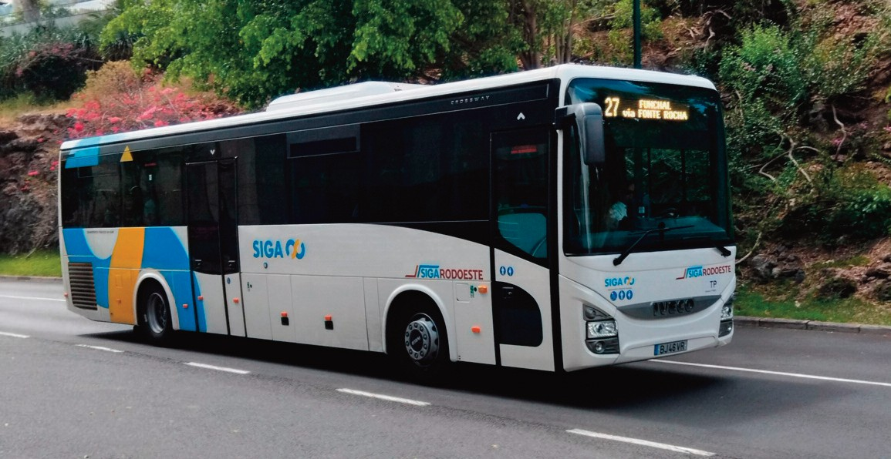
One of Rodoeste's new Ivecos on route 27 from Caminho de Ferro speeds through the Lido area heading for Funchal. Photo: Barry Rennison.

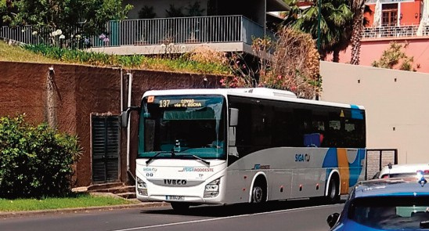
Fleet numbers don't appear to be used, this one heads for Covao via Rocha on route 137.
Photo’s: Barry Rennison.

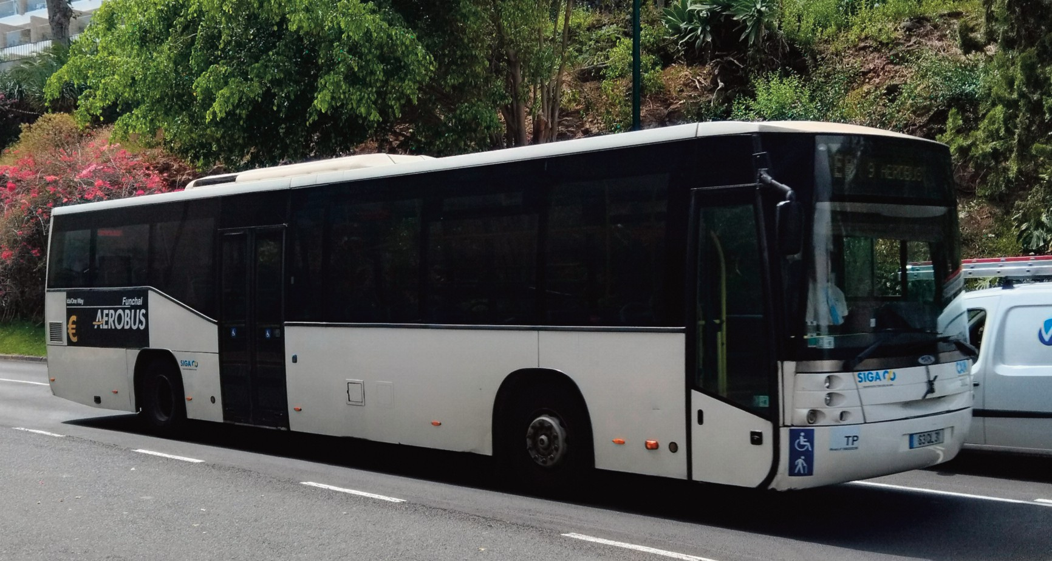
Sam's Aerobus runs a regular service from many areas on the island to the C r i s t i a n o Ronaldo airport in Funchal.

I was particularly looking forward to observing and travelling on these during my latest visit. Thus, on a visit to the capital, Funchal I waited for a number 1 route bus to Cabos de Lobos to return to my hotel. First to arrive was a yellow bus, so I let that one go, and didn’t have long to wait for the usual accompanying bus following on its tail – one of the new ones!

On entering and paying my 2 euro fare I immediately sensed that I would be unimpressed with the new buses. No low floor, three high steps up to pay driver and finding a seat there was, unbelievably another step up to the seat from the gangway. Seats were very close together, hardly any comfort for legroom for big passengers!

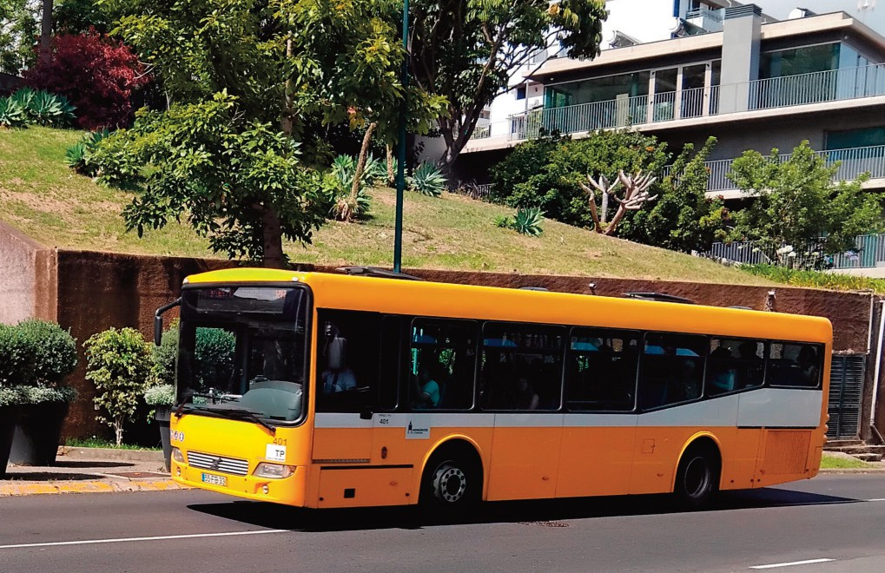
Yellow bus no 410 thunders trough the Lido district. Photo: Barry Rennison.

The driver set off at the usual high speed, to chase the bus he was following. This led to the next problem, I almost slid off the edge of the seat. At this stage I was made aware by two local passengers sat nearby to make the ’necessary’ use of the armrest attached to the seat. This had to be pulled up in order to keep passengers safe and not fall off into the aisle when cornering.

It wasn’t long before I saw my approaching hotel and pushed the stop sign above the seat and made my way to the centre exit door. That was a further problem being a coach chassis, the high floor necessitated another three steps to exit the bus. To be fair the driver was patient and gave me sufficient time to alight safely.

To sum up, the new buses – were all that was new, everything else was very much the same. I was definitely not impressed by them at all. It is obvious that surprisingly there are no access regulations for disabled passengers on buses in Maderia. How- ever, there was one feather in their cap, like the UK they had a maximum fare of 3 euros for any journey, one of which was a service from east to the west of the island, a journey time of 65 minutes – not bad value.

On the debit side, I cannot see that this new fleet will last the incredible number of years in service like their predecessors – no chance!

